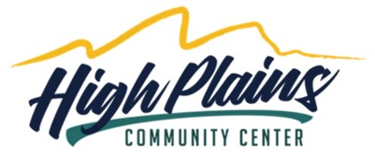 | 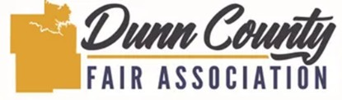

VOLUNTEER PHOTO & MEDIA RELEASE FORM
Volunteer Name:
Phone: Email:

I hereby grant High Plains Community Center / Dunn County Fair Association permission to take photographs and/or videos of me during events, activities, or while on the premises. I understand that these images may be used, without compensation, for promotional purposes including but not limited to social media platforms, the organization’s website, printed materials, and other marketing or publicity efforts.
I waive any right to inspect or approve the final use of the images or recordings. I release High Plains Community Center / Dunn County Fair Association, its representatives, and assigns from any liability arising from the use of such images.
- ☐ YES, I give permission
- ☐ NO, I do not give permission
Volunteer Signature:
Date:
If the volunteer is under 18 years of age, a parent or guardian must complete the section below:
Parent/Guardian Name:
Signature:
Date:

